**COSC 420:** Biologically-Inspired Computation

Project 5 - “Particle Swarm Optimization”

Clara Nguyen

Table of Contents

1. Synopsis 4

2. Development 4

3. How it works 5

3.1. General Algorithm 5

3.2. Algorithm Synopsis and Breakdown (Undergraduate Portion) 6

3.2.1. Particle Position Movement 6

3.2.2. Personal and Global Best 7

3.2.3. Computing Error 8

3.2.4. Determining Convergence of a System 8

4. Experiment 1: Epoch vs. Inertia 9

4.1. Synopsis 9

4.2. Simulation Parameters 9

4.3. Simulation Observations and Results 10

4.4. A Visual Proof Of Concept 12

4.5. Exploring the Impossible: Inertia Values Over One 13

4.6. Predicting Error 14

4.7. Determining when convergence occurs 15

5. Experiment 2: Exploring Multiple Functions 16

5.1. Q2. A Case of Multiple Maxima 16

5.1.1. Simulation Parameters 16

5.1.2. Simulation Results (And Extra Credit) 17

5.2. Q3 (The Ripple) 19

5.2.1. The Catch and Flaw in the Algorithm 19

5.2.2. Simulation Parameters 19

5.2.3. Observation and Discussion 20

5.2.4. How to improve Particle Swarm Optimization 21

6. Experiment 3: Transcending Dimensions. The 4th dimension 22

6.1. The Theory 22

6.2. The Proof By Visualization 23

6.2.1. Simulation Parameters 23

6.2.2. Simulation and Discussion 23

6.3. Can we go even further (Fifth-Dimension, Sixth-Dimension, etc.)? 24

7. Conclusion 26

8. Project Files and Submission Information 26

8.1. Source Code Files (C++, GML, HTML/JS/CSS) 26

8.1.1. C++ Implementation 26

8.1.2. GML Implementation 27

8.1.3. WebGL Implementation 27

8.2. Excel Documents 27

8.3. CSV Experiment Files 28

8.4. Docx Master File 28

# Synopsis

In this project, I explored the Particle Swarm Optimization algorithm, and how can be applied.

Generally, this algorithm involves placing particles in a “search space” and having them search randomly for a place that gives them the highest fitness. In our case, this is a 3D equation’s maximum value.

# Development

The simulator was written **three times** in **three** different languages:

* **C++** - Initial Implementation. Console only. Prints out error values to console.
* **GML** – GUI via Direct3D. 2D Grid for showing visually how particles move around.
* **HTML/CSS/JavaScript (WebGL)** – GUI via a web port of OpenGL that runs in your web browser. This is the implementation that was used to run experiments for this paper.

All three implementations will be in the “src” directory under their respective language. The GUI ones (GML & JS [WebGL]) will allow you to configure the simulation from the application. The C++ version takes the following parameters:

|  |
| --- |
| ./pso iterations size particles inertia cognition social max_velocity |

In the GUIs, the number of iterations is infinite, though we can only consider a certain number of iterations for our observations later on. In the C++ implementation, a default setup (as par with the project writeup) will look like this.

|  |
| --- |
| ./pso 50 100 40 0.99 2.0 2.0 1.0 |

It will output text in the format of a CSV file, which can be piped to a CSV file afterwards. All three simulators will have some way to write a CSV file, but the C++ one is the most straight forward.

# How it works

## 3.1. General Algorithm



***Figure 1.*** *Pseudo Code for the Simulator.*

For all three simulators, the program structure was written with pseudo code from Figure 1 in mind. The program abides by equations was given to us in a project writeup and is shown in Figure 2.

***Figure 2 (Top) and 3 (Bottom).*** *Equations Q1 and Q2 given in the Project Writeup.*

***Figure 4.*** *Variables required for equations in figures 2 and 3.*

## 3.2. Algorithm Synopsis and Breakdown (Undergraduate Portion)

The equations Q1 and Q2 are both three dimensional functions that request 2 variables, being and explicitly (assuming and are predefined). As such, these equations can be graphed via applications such as Wolfram, Matlab, etc. In the cases of a visual graph, the maximum can easily be found by simply looking. However, the computer doesn’t think in the same way that we do. The Particle Swarm Optimization algorithm aims to find that maximum through particles that simply seek out the position that gives each particle the best “fitness”.

### 3.2.1. Particle Position Movement

The equations for *pdist* and *ndist,* given in Figure 4, are two-dimensional distance formulas. Meanwhile, *mdist* is a modification of the distance formula. The particles will go in random directions based on a random number generator, but the “randomness” is biased toward higher fitness. The next position of each particle is calculated by the following equation:

***Figure 5.*** *Velocity Computation Equation (Applies to all axes, including X and Y)*

In each update step, the velocity is computed with the formula in Figure 5. It is then normalized to conform to the maximum velocity specified in the simulation parameters. After normalization, the velocity is simply added to the particle’s position on all axes. The particle’s personal best and the simulator’s global best are then updated, along with the percentage of error. In our case, the percentage of error will determine whether the system has converged.

### 3.2.2. Personal and Global Best

The way how our “biased” random search works is by updating the and variables. Though, the decision to go to one of those variables is determined by the following parameters:

* **Cognition** - Influence to seek
* **Social** - Influence to seek

The two randomly chosen numbers between 0 and 1 will determine the influence that these variables have on the simulation. The variables for the best positions can be updated mid-simulation by the following pseudocode:



***Figure 6.*** *Pseudo Code for updating Personal Best*



***Figure 7.*** *Pseudo Code for updating Global Best*

If we look back at the formula in Figure 5, it is observed that the particle will attempt to seek either the or the . It will take the difference between those variables, and the current position, and multiply by cognition or social variables appropriately.

### 3.2.3. Computing Error

Error is surprisingly simple in this simulation. In our update step, set the error for all axes to 0. Then, for each particle, append the following pseudocode after updating the personal and global best:



***Figure 8.*** *Pseudo Code for updating Error*

After the particles are done being updated, the error is normalized by applying the following equation:

***Figure 9.*** *Formula for normalizing the error on any axis.*

The equation in Figure 9 is applied to both the X axis and Y axis.

### 3.2.4. Determining Convergence of a System

The error value can be used to help determine if a system has converged. If it is under an extremely low value, all of the particles are assumed to be extremely close to each other, and thus near the global maximum of the function given. When this happens, we can conclude that the system of particles has “converged”. Unfortunately, this assumption is not a guaranteed one. There exist cases where a particle system will never converge under these circumstances. To counter this, a “Max Iterations” variable was added to the simulator to cut it off after the epoch goes over this specified value.

# Experiment 1: Epoch vs. Inertia

## 4.1. Synopsis

Epoch is simply the number of times that the simulator has had to go through each particle and update their position, velocity, and personal best values. It can also represent the number of times that the error was updated. Point being, **epoch is a measurement of time.** And time is flowing at a constant rate throughout the simulation. This makes epoch an extremely valuable variable in graphing information. For this experiment, we will be comparing epoch to 12 different runs of the simulator, each with a different value of inertia specified.

## 4.2. Simulation Parameters

The following parameters were used in the WebGL implementation of the Particle Swarm Optimization simulator:

* **Equation:** Q1
* **Grid Size:** 100
* **Particles:** 50
* **Inertia:** {0.1, 0.2, 0.3, 0.4, 0.5, 0.6, 0.7, 0.8, 0.9, 0.95, 0.99, 0.999, 1.0}
* **Cognition:** 0.1
* **Social:** 1.0
* **Max Velocity:** 1.0
* **Max Iterations:** 500

The only variable that changes in this experiment is, obviously, the inertia variable. The equation in Figure 2 (Q1) will be used as well, as it is the simpler of the two to make an observation with. The equation in Figure 3 will be observed in future experiments.

## 4.3. Simulation Observations and Results

All of 11 inertia properties did not change the overall pattern of how error decreased per update step. They all declined, as predicted, and approached 0. The WebGL simulator exports CSV data relating to Error X, Error Y, Global Best X, and Global Best Y. To plot this, we need to get the error down to a single value, as opposed to two values. To do this, we simply use the distance formula:

***Figure 10.*** *Error Computation when given 2 dimensions.*

After plotting the data in Excel, we can generate a graph of all of the error values for every single run of the experiment.

***Figure 11.*** *All 500 error computations for runs 1 through 13.*

As previously mentioned, the pattern is consistent among runs 1 through 13. They approach 0. However, this graph can give more detailed information if the range is more carefully chosen. Because we know it’ll eventually approach a value near 0, we can set the vertical axis to a much more reasonable value… so let’s set it to go from 0 to 6.

***Figure 12.*** *All 500 error computations with a focus on lower values.*

Now we are able to actually do some reasonable analysis on what we were given. Thankfully, we are also able to do this visually due to WebGL. Experiments with a lower inertia were able to hit an error of 0. The global maximum of the function is at (20, 7), which they were able to find.

However, as we approach an inertia of 1 (without actually hitting it), it seems to have a major impact on how fast the simulator is able to converge down to a single point. This is especially the case with runs where the inertia is 0.9 or higher (Runs 9 and beyond). This is why the simulation was configured to cut off at 500 updates. It appears that it would go almost infinitely without a cutoff.

## 4.4. A Visual Proof Of Concept

Running the WebGL simulator, we can actually see, visually, how the cluster of particles move. We can also use this visual aspect to prove our observations about inertia and its relation to how fast it can converge down to a single point… if ever.

|  |  |
| --- | --- |
| **Run 1** | **Run 11** |
|  |  |

***Figure 13.*** *Visual Comparisons of Run 1 to Run 11 after the 500th update.*

From the visual analysis, the particles are moving around the point at (20, 7) but are, indeed, unable to approach that point and stabilize there. After leaving the simulation to run for several hours, the particles still have not been able to converge, with the error being seemingly random. Of course, if we look at the equation given in Figure 5, a higher inertia would explain why this phenomenon occurs. Here’s a segment of the equation:

***Figure 14.*** *The first segment of the equation featured in Figure 5.*

The lower the inertia, the faster the velocity slows down. When it is at a value like 1.0, this multiplication is essentially voided. However, what would happen if we were to expand inertia to values beyond 1.0?

## 4.5. Exploring the Impossible: Inertia Values Over One

We will add two new runs into the series: 2.0 and 5.0. This makes for a total of 15 runs. It turns out that, if we set inertia to higher values, the range of error actually multiplies and circles around the point. The initial graph, including all 15 runs looks the same as the previous one. Therefore, it will not be shown (It is included in the Excel document, regardless). However, the interesting case comes when we set the range of the vertical axis down to 0 to 60.

***Figure 15.*** *All 500 error computations with a focus on lower values.*

|  |  |
| --- | --- |
| **Run 11** | **Run 15** |
|  |  |

***Figure 16.*** *Visual Comparisons between Run 11 and Run 15 after the 500th update.*

## 4.6. Predicting Error

***Figure 17.*** *Relation between Epoch and Inertia based on the 500th update for all runs.*

Based on the graph above, I began to investigate if there was a way to predict the error based on the value of inertia given. Aside from the values prior to 1, it appears that there is a regression that can be used to predict the error for values for 2.0 and beyond. It turns out, there is a relation.

***Figure 18.*** *Quadradic Regression Formula for the relation between Inertia and Error.*

We can prove this by simply running more tests.



***Figure 19.*** *Table comparing simulation to equation in Figure 18.*

The results are not perfect. As shown in Figure 15, the results are unstable, but are shown to be fit within a certain range. We could get more accurate by simply taking the average of each equation, but seeing as we get accurate results among those 7 values of inertia (especially up to 1000), the equation will suffice. It should also be noted that the inertia should never actually go over 1. Though, the fact that a pattern actually exists for values above 1.0 is an interesting observation. The fact that the particles orbit around the global maximum, and how that orbiting radius gets larger as the inertia gets larger is a nice effect. It’s also possible to take the average of every single point and get the global maximum through this method, as all of the points are orbiting around it.

## 4.7. Determining when convergence occurs

Saving the simplest observation for last, we can use the data given to determine if inertia affects when the system converges. We will use a threshold or error to determine whether the system has converged or not. In this case, an error below 0.05 will suffice.

***Figure 20.*** *Moments each run converged.*

The runs where the inertia was 0.95 or higher did not converge at all within the 500 updates.

# Experiment 2: Exploring Multiple Functions

Q1 (Figure 2 in Section 3.1) was only one equation that happened to have a single maximum. However, there are other functions that can be plugged into the simulator. Q2 exists, and we can also implement our own equations as well.

## 5.1. Q2. A Case of Multiple Maxima

Q2 has a local maximum at (-20, -7) and a global maximum at (20, 7). This equation is set to prove a point. The algorithm given is not guaranteed to always go to the global maximum. To prove this, we will run multiple instances of the simulator and see how it reacts:

### 5.1.1. Simulation Parameters

The following parameters were used in the WebGL implementation of the Particle Swarm Optimization simulator for this experiment:

* **Equation:** Q2
* **Grid Size:** 100
* **Particles:** 100
* **Inertia:** 0.2
* **Cognition:** 0.001
* **Social:** 1.0
* **Max Velocity:** 0.5
* **Max Iterations:** 250

The simulation was run only a handful of times and it was rerun until the desired results were obtained. These CSV files can be found in “experiments/02_MultipleFunctions”.

### 5.1.2. Simulation Results (And Extra Credit)

Two specific runs were chosen to show examples of how it may pick the local maximum as opposed to the global maximum, and vice versa. The figure below shows Run 1 and Run 2 of this experiment.

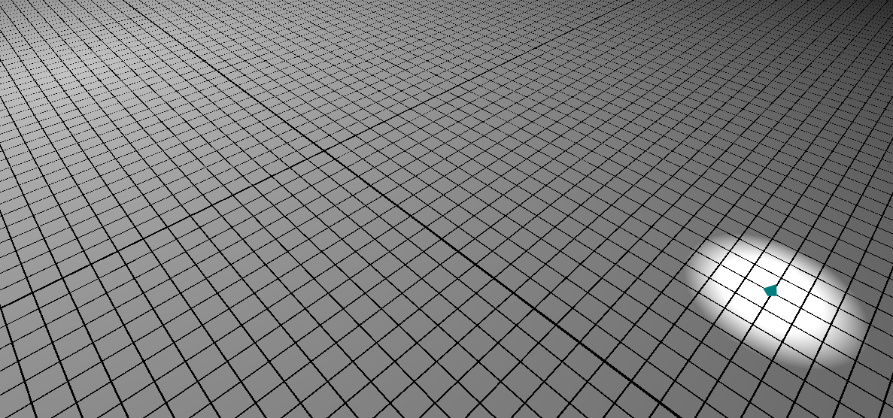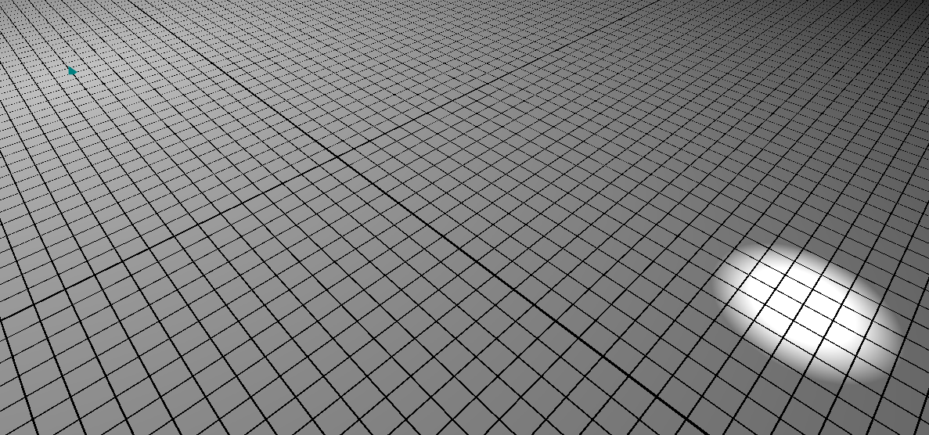

***Figure 21 (Top) and Figure 22 (Bottom).*** *The algorithm doesn’t guarantee that particles always go toward the global maximum. Top image shows the particles at the global maximum toward the bottom right. Bottom image shows particles at a local maximum toward the upper left.*

Even more interestingly, there exist situations where points get stuck in between the two maxima in the equation. This is commonly the case when the cognition and social values are the same. For Run 3, the particle number was 50, the inertia was 0.5, and both the cognition and social values were set to 0.1. The simulation ends up getting stuck and never converging.

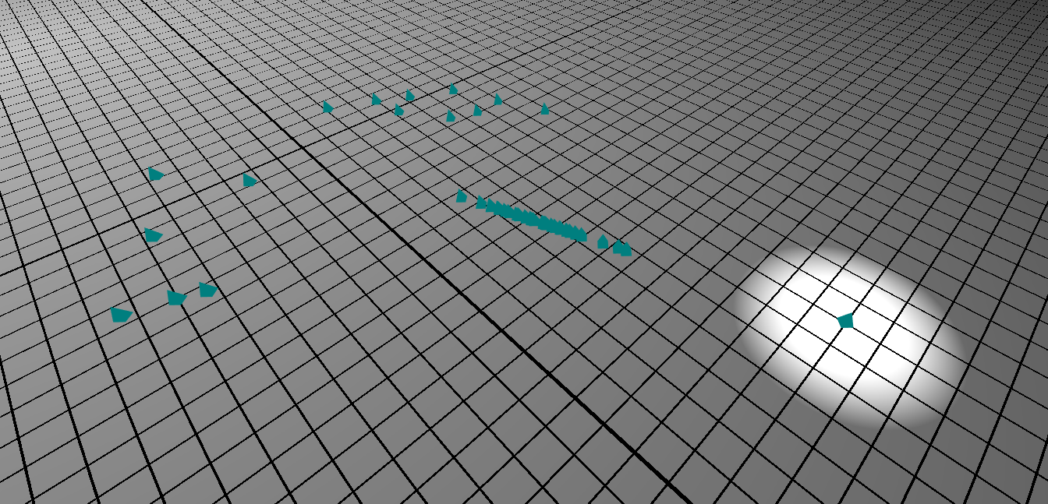

***Figure 23.*** *Run 3, a situation where a system never converges.*

Thankfully, the algorithm is stated to have this as a possible outcome. Though it can be avoided by increasing cognition or social values. Increasing the social variable to 1.0 forced the values to never get stuck. Meanwhile, increasing cognition to 1.0 (leaving social at 0.1) did not prevent the simulation from not converging.

**Extra Credit:** The main observation is that this proves that the algorithm isn’t capable of guaranteeing success in finding the data we are looking for consistently. This is primarily because it is inspired by personal best as well as global best. This is why, when the social variable was set to 1.0 (as it affects the attraction to the global best), **it gave the guarantee that the particles will all converge onto a certain point eventually.**

## 5.2. Q3 (The Ripple)

Now it’s time to get creative. We will use a custom function that builds off of the sine and cosine trigonometric functions and see how it acts in the simulation. Behold:

***Figure 24.*** *Q3 (The Ripple), a 3D equation with infinite maxima.*

This equation is accessible in the WebGL simulation in the “Equation” tab, being labeled “Q3”.

### 5.2.1. The Catch and Flaw in the Algorithm

This function is shaped like a ripple (hence the name), but it has an interesting twist to it, because it has an infinite number of maxima that is defined depending on the range of the search area. Its maximum areas are guaranteed to be at corners of the search area, and it can be any one of the corners depending on which one is found first by the algorithm. Remember, the position of the particles in search space is determined by a random number generator. The moment one particle finds the highest value, all of the other particles will approach that position unless an even higher position is found. Because there are an unlimited number of maxima at that radius, the maximum point found by the search will be different every single time.

### 5.2.2. Simulation Parameters

The WebGL simulator will use the following configuration to run “The Ripple” experiment:

* **Equation:** Q3
* **Grid Size:** 100
* **Particles:** 100
* **Inertia:** 0.5
* **Cognition:** 0.1
* **Social:** 1.0
* **Max Velocity:** 1.0
* **Max Iterations:** 200

### 5.2.3. Observation and Discussion

“The Ripple” went through three tests. For simplicity, we will show a two-dimensional graph of where the points are at, as opposed to a three-dimensional screenshot.

|  |  |  |
| --- | --- | --- |
| **Run 1** | **Run 2** | **Run 3** |
|  |  |  |

***Figure 25.*** *The three runs of “The Ripple”, showing how it can converge to different points.*

From a handful of tests, it is extremely easy to say that this points out a huge flaw in the Particle Swarm Optimization algorithm given to us. Because it is randomly determined, and not fixed, any result that has an infinite amount of maxima will give a different result every time. Of course, it does find a maximum value in the equation, but the value it returns is different, because it’s at a different position.

We can look at graphs of the three runs to emphasize what’s happening:



***Figure 26.*** *CSV Output from the three runs of “The Ripple”.*

The error in each of these are unstable as well, because not all particles have converged at the 200th update of the simulation, as shown by Figure 25. The point of emphasis, though, is in the global best. If we take the equation and plug these values in, we get the same results for them all:

***Figure 27.*** *Results of Q3 in Runs 1, 2, and 3.*

### 5.2.4. How to improve Particle Swarm Optimization

There are a few ways to counter this flaw of multiple/infinite maxima. We could set up a seed so the results are the same every time. We can also split up the particles into “teams”, which have their own global maximums to seek out. Lastly, we can have the velocity computation include a “local” variable in it (aka, the Graduate part of this assignment) to form neighborhoods of particles. These properties apply to the simulator for the current and specified algorithm only. There are many variations of the Particle Swarm Optimization algorithm that improve on the original concept and consider errors such as these. But the main fact is that Particle Swarm Optimization is *not guaranteed* to find the absolute and global maximum in our simulation if there is more than one.

# Experiment 3: Transcending Dimensions. The 4th dimension

## 6.1. The Theory

This algorithm can be expanded into support an infinite number of dimensions. As long as the equations given support N dimensions, the search space is in N dimensions, and the particles are allowed to roam freely in those N dimensions, it will work. Therefore, for our last experiment, we will transcend a dimension. In the previous experiments, we were given equations that returned a Z value. The goal was simple. Just have the particles seek the spot where the function returns the best value. However, in theory, we can do this with a four-dimensional formula as well, and have it display in three-dimensional space, just like our previous example had a three-dimensional formula display on a two-dimensional plane.

Thankfully, the WebGL simulator was written with this extension in mind, and we can expand the simulator into the third dimension by simply modifying the formulas to tack on an additional dimension. Equations such as the distance formula are easily expandable. Meanwhile, equations for velocity above were specified as “handling for all axes” for a reason. In the simulator, a value was computed for each dimension, being the X and Y axes. But since we are transcending a dimension, we can simply add on a third computation to calculate the Z axis value. This will work for Z velocity, Z positioning, Z personal best, and Z global best.

For the sake of simplicity, we will use a modified version of Q1, and have its max value shown.

***Figure 28.*** *Q1 equation extended to the fourth dimension with max (pdist and mdist embedded).*

## 6.2. The Proof By Visualization

The modified Q1 in Figure X equation will, in theory, allow the simulator to seek out the maximum value. This function will return a value in the fourth dimension, but it can be represented in the third dimension, as the value that has the maximum is in three dimensions. The simulator at “src/web/index4d.php” was made specifically for this test.

### 6.2.1. Simulation Parameters

* **Equation:** Q1 (Modified)
* **Grid Size:** 100
* **Particles:** 100
* **Inertia:** 0.7
* **Cognition:** 0.1
* **Social:** 1.0
* **Max Velocity:** 1.0
* **Max Iterations:** 100

### 6.2.2. Simulation and Discussion

|  |  |
| --- | --- |
| **Finding Maximum** | **Converged. Solution Found** |
|  |  |

***Figure 29.*** *Simulator finding maximum value in four-dimensional function.*

As shown by the figure above, the values converge to the function maximum at (20, 7, 7), which is indeed the maximum value for that function. Because the inertia value was 0.7, this simulation can be compared to Experiment 1’s Run 7, which has matching parameters.

***Figure 30.*** *Comparison of Convergence between 2D Experiment 1: Run 7, and 3D Experiment*

Experiment 1 Run 7’s experiment converges at an epoch of 76. Meanwhile, in Experiment 3, the first convergence of the particles occurs at an epoch of 92. An extra dimension does mean that there is an extra bit of computation added into the error. So it would make sense that it converges to 0.05 or below at a later time.

More simulations can be done, but it’s already been demonstrated that it works on 4D functions.

## 6.3. Can we go even further (Fifth-Dimension, Sixth-Dimension, etc.)?

Yes. As stated earlier, the algorithm allows for an infinite number of dimensions. This is true as long as the equation given, the search space, and the particles all support that many dimensions. While I will not be giving an in-depth analysis of a 5D function, I decided to run one just to prove that we can go further, if we wanted.

***Figure 31.*** *Q1 equation extended to support five dimensions (pdist and mdist embedded).*

The maximum of this function is, unsurprisingly, located at (20, 7, 7, -12). This is a fourth dimensional coordinate. We will use the same configuration as demonstrated in Section 6.2.2, except we will change the maximum epoch to 150. The simulation was run and, by the 118th update, it successfully found the global maximum at (20, 7, 7, -12).

The simulator for the fifth-dimensional computation can be located at “src/web/index5d.php”, and the data file consisting of the run used in this analysis can be found at “experiments/03_TranscendingDimensions/run5d_01.csv”.

**Note:** Because your computer display is only capable of displaying 3D graphics, and also only representing it on a 2D screen, a lot of information is lost while drawing to the simulator. Therefore, when using the 5D simulation, do not trust what is visually shown. Go only based on what the CSV file states. The simulator simply “drops” the “w” coordinate while drawing to the screen. Thankfully, the 4D simulator can be represented in 3D space (as the function is returning the fourth dimensional coordinate), so it does not have this issue.

# Conclusion

It is very intriguing to be able to use this algorithm to find global maximums in N-dimensional equations. The application can also be tweaked to find global minimums, or any other kind of data that we seek. It isn’t limited to just global maximums. The flexibility of using particles in a search space allows for nearly unlimited possibilities, and it is fairly accurate too. The only consequence of this algorithm, as discussed in Experiment 2, is that it isn’t guaranteed to find the data it’s looking for in some cases. If there are two or more maxima, for instance, it is possible that it will stop after finding the local maxima, as opposed to the global maxima. Though, with enough tweaking of the variables in the simulator, I can see this algorithm being a very effective and accurate way to solve problems that do not have another effective solution in a reasonable time.

# Project Files and Submission Information

## 8.1. Source Code Files (C++, GML, HTML/JS/CSS)

You can find the source code to the three simulation implementations in the “src” directory. The directory categorizes the source code files into the following:

* **cpp** – C++ Source Code Simulator
* **gml** – Game Maker Language GUI Simulator for Windows
* **web** – HTML/JS/CSS simulator. This can also be accessed on the web at the following URL: <http://web.eecs.utk.edu/~ssmit285/private/420p5/index.php>

### 8.1.1. C++ Implementation

The C++ simulation is incomplete, very barebones, and was made to test the algorithm’s initial implementation. The GML and Web simulators are complete and feature-rich. However, the source code of the simulator was included for completeness. A “makefile” is also included for the C++ source to compile it. Though I would not recommend using this version of the simulator.

### 8.1.2. GML Implementation

The GML implementation must be compiled into an executable through software called “Game Maker 8.0 Pro” on Windows. To make things simple, the compiled executable is included in the “bin” directory. It only runs on Windows XP and above… with DirectX 9 and above. The source code file that Game Maker 8.0 understands is pso.gmk. The other files are there to help with when the files were pushed via version control, and contain the source code in a plain text or XML format that is humanly readable.

### 8.1.3. WebGL Implementation

The WebGL implementation was written with HTML, CSS, and Javascript. It is also wrapped around with PHP files. This implementation is the most complete, most configurable, and most flexible. It has a 3D version, a 4D version, and even a 5D version. Though the 4D and 5D implementations are only working with equation Q1. The implementation is powered by a 3D WebGL Wrapper engine I wrote myself for another UTK class (COSC 456: Computer Graphics) a year ago. The 5D implementation was only written to do raw computation. Whatever is displayed on the screen isn’t relevant since the 4th dimension is dropped from being displayed.

## 8.2. Excel Documents

In the “experiments” directory, there is an “experiments.xlsx” file, which contains all data used in this report. The XLSX file also contains all graphs and most of the CSV data in a friendly format that can be simply read in Microsoft Excel.

## 8.3. CSV Experiment Files

This paper has had three experiments done. The data is stored in the “experiments” directory under the following directory names:

* **01_EpochVsInertia** – Experiment 1: Epoch Vs. Inertia
* **02_MultipleFunctions** – Experiment 2: Exploring Multiple Functions
* **03_TranscendingDimensions** – Experiment 3: Transcending Dimensions

Each of these directories have CSV files for the individual runs used in this report and all analysis. Experiment 1 simply has all 15 runs of the simulator with the properties specified in Section 4.2. There is also a README.md in this directory to explain what each of the files represent. Experiment 2 has three simulations for both Q2 and Q3, which are specified by filename. Experiment two has 2 simulations: One for 4D, and one for 5D.

## 8.4. Docx Master File

This document, itself, has a master file included in the “docs” directory under “5 - Particle Swarm Optimization.docx”. There are also two additional directories in the “docs” directory that include other information that the master document used:

* **embedded** – Embedded Excel tables that were imported into Word.
* **img** – Raw images that were captured during experimentation and imported into Word.

The images and original table documents are all stored in a lossless format for archival purposes. The images are in their full resolution as well.